Lappeenrannan teknillinen yliopisto

School of Software Engineering

Sofware Development Skills

<Hyoseo Jang>, <000719647>

LEARNING DIARY, <Software Development Skills: Full-Stack> MODULE

**10/03/2022**

Today, I learned how to start up the first MEAN Stack project. For the first lecture, I got to know that the purpose of this course is to develop my project and learn about Node.js. In this lecture, I tried to make my environment, but because of the version, I struggled hard time. Also, I learned about the components of Node.js and use it.

**17/03/2022**

I learned the core elements of MongoDB, and develop the project. I learned about Insert, Count, Update, and Limit functions and I faced errors of Increment at that time. Finally, I found that I need to include automatic increment in the code. While handling the unexpected errors, I found that debugging is a necessary part of coding. After that, I continued to watch the second part till the end.

**24/03/2022**

Today, I learned about Express JS and it is a type of a server-side or back-end. To deal with data that users define, I need to use basic server syntax. And in the third part, I got to know how to use Express router, REST API, nodemon, and static. Except for this lecture, I tried to make other examples using nodeman, and it was helpful to develop the skills of Express JS.

**27/03/2022**

I got to know the reason of using Angular and practice basic codes. While learning Angular framework fundamentals and Angular CLI, I realized of Angular’s Components and Services. Also, I practiced Events, HTTP and Routing from the video leacture.

**<MongoDB practice record>**

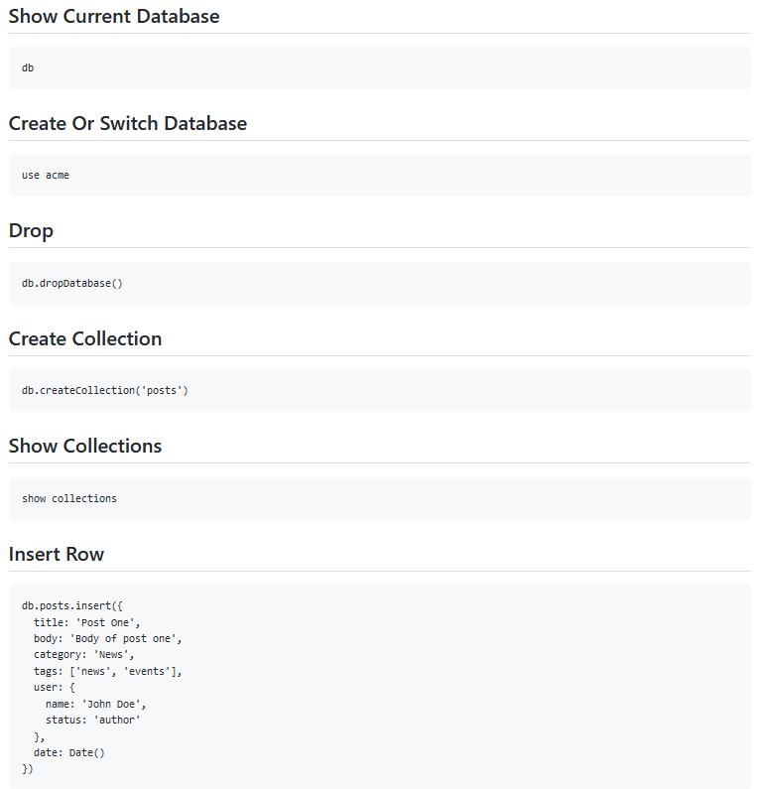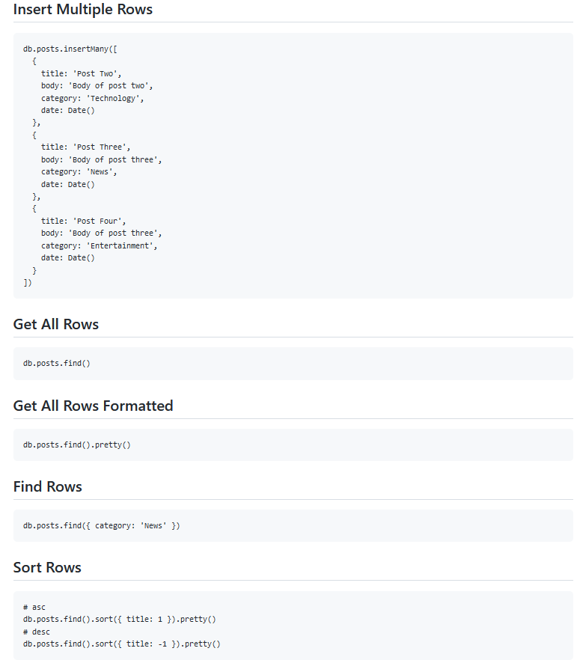

**Building MEAN Chat Application**

**1. Features**

1) Register and authenticate users using JSON web tokens

2) Join a common room where you can chat with all the registered users

3) Open 1on1 private conversations with a user of your choice

4) Notifications for messages on background conversations

5) Have a pleasant UI/UX built to look awesome from mobile to desktop

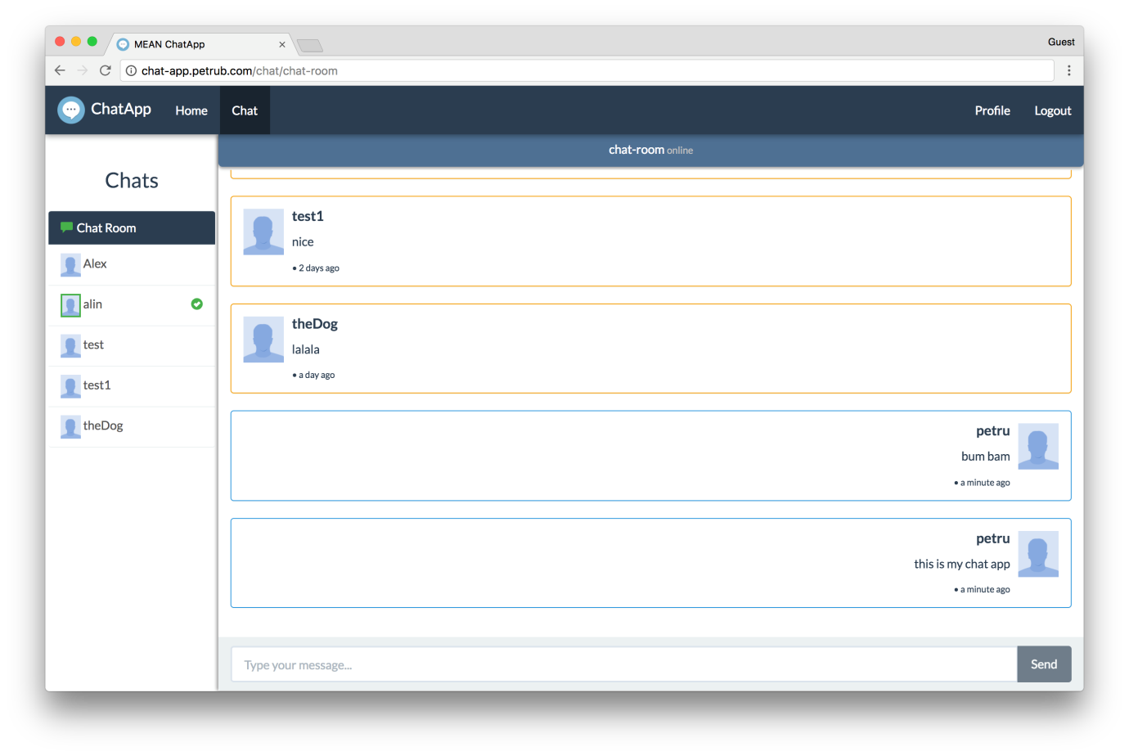

**2. How it works**

On the client-side users can create accounts that will be stored in the database. Then users can authenticate with the given credentials, if those are correct the server sends a unique token to the client. The client stores it for use on restricted backend route requests.

Once authenticated, the server creates a socket bidirectional connection with the client to facilitate the chat functionality.

Every time a user sends a message, this goes to the server which redirects it to the desired respondent. Also every time a user enters or leaves chat, the server announces all the connected clients.